**Problem Statement:**

A retail window company is losing business due to improper performance of individual dealers. The goal of this analysis is to figure out which window dealers are lacking in sales performance, find the reasons for the lack of sales, and to recommend possible solutions to help increase the bottom line.

**Data set:**

From the data set of 40 column attributes and 229 rows, after visual data screening, it was observed that a few key columns indicate how well a dealer is performing.

**Analysis:**

To understand which columns are relevant to the analysis, a heat map was created.

From the heat map, it can be concluded that the darker shaded squares are weakly correlated which means they are of less relevance.

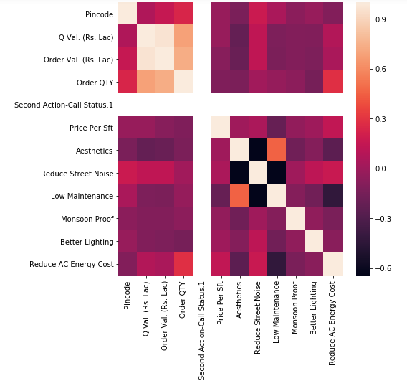

**Data cleaning:**

On looking at the data, we found that:

1. There were two agencies with the name of Pearlson/pearlson.
   1. Solution: We solved this problem by replaced the “pearlson” keyword with “Pearlson” assuming that it was a typo.
2. We wanted to look at data only for dealers
   1. Solution: A separate data frame was created where the allocation status was set to the dealer and we found the dealers that were not “direct” to get all of the individual dealers.
3. There were certain typos and inconsistencies with the remarks column.
   1. Solution: These were corrected in a data cleaning process
4. Missing values in remarks column. We found 4 missing values in this column.
   1. Solution: We solved this by filling those missing values with mode from remarks column.

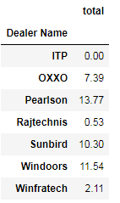

The approach we took to find out the underperformers was to look at which dealers offered the highest value in terms of revenue(order value). We achieved this by segregating the data according to dealer name and calculated the respective order values.

*Note- The total value is in Rupees (lacs)*

Since we do not have the amount of profits each dealer is making per order, we cannot properly use this as an indicator of how well the dealer is performing.

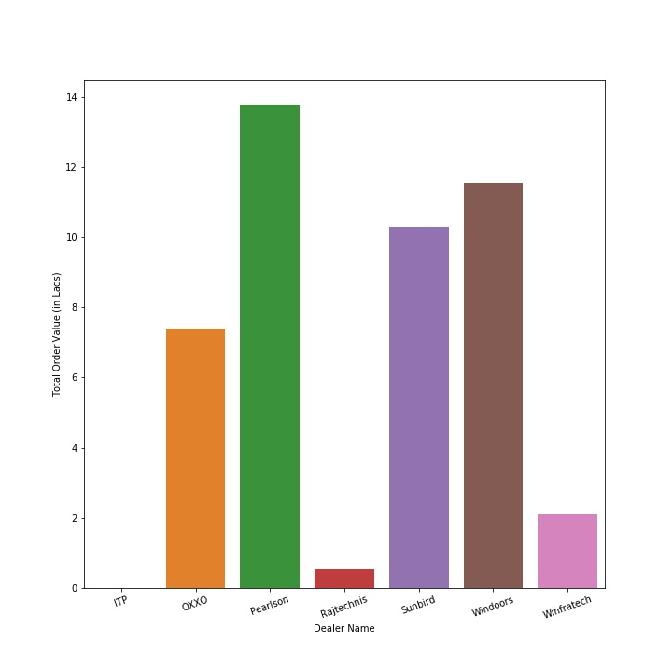

What we decided to do after realizing that the order value vs dealer quotations was insufficient was to look at how well the business is performing by looking at the conversion ratio (the wins divided by the total quotes given).

*Note- Conversion rate in percentage*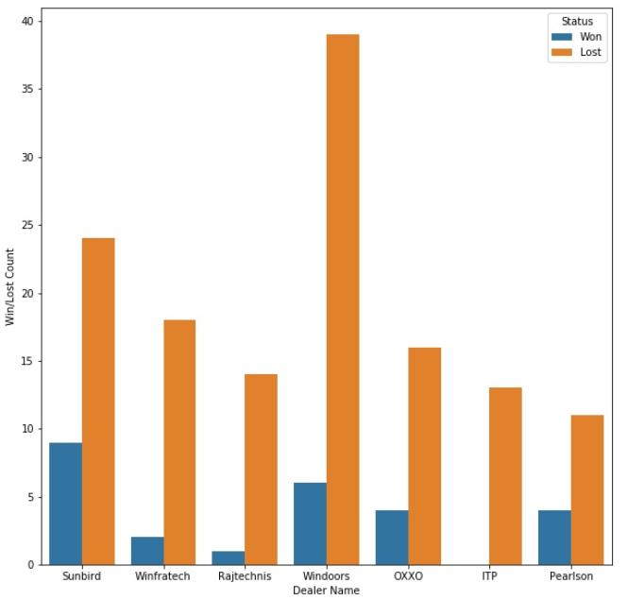

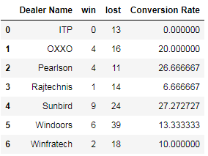

We can conclude how each dealer is doing relative to the other dealers. If certain dealers are below the average conversion ratio, those dealers will be looked at in greater detail to understand why they are underperforming.

As a **threshold (14.848%)**, we took the average of these ratios. The below mentioned dealers are the underperforming ones.

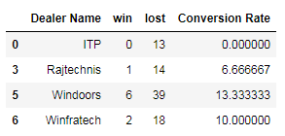

Upon further analysis, we found out the major issue for under performers was the price issue.

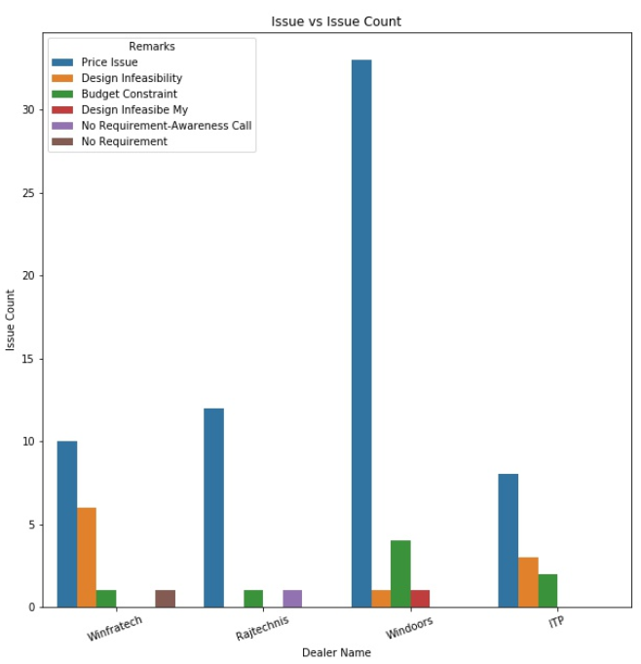

For all of underperforming dealers, the main reason for the price issue is because of UPVC material being too expensive.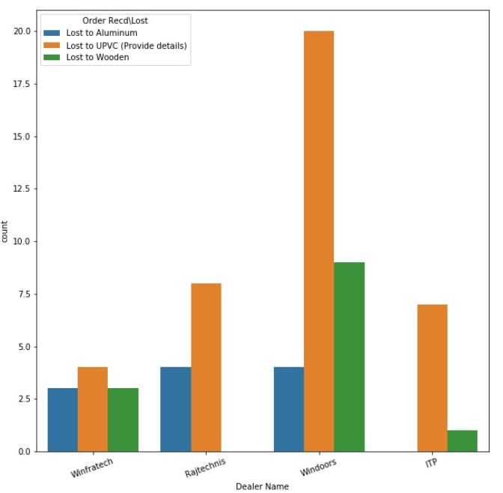

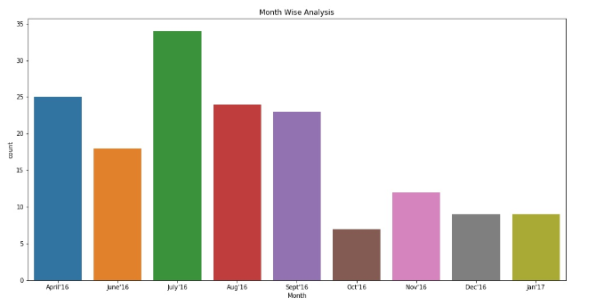

From the above graph, we can see that most of the counts are done during the summer months rather than winter months because most construction/renovation is done during the summer.

**Recommendations:**

1. From the above graph, to increase sales quantity, we can recommend the dealers to focus their efforts on digital marketing, and provide incentives for customers who refer their friends or family.

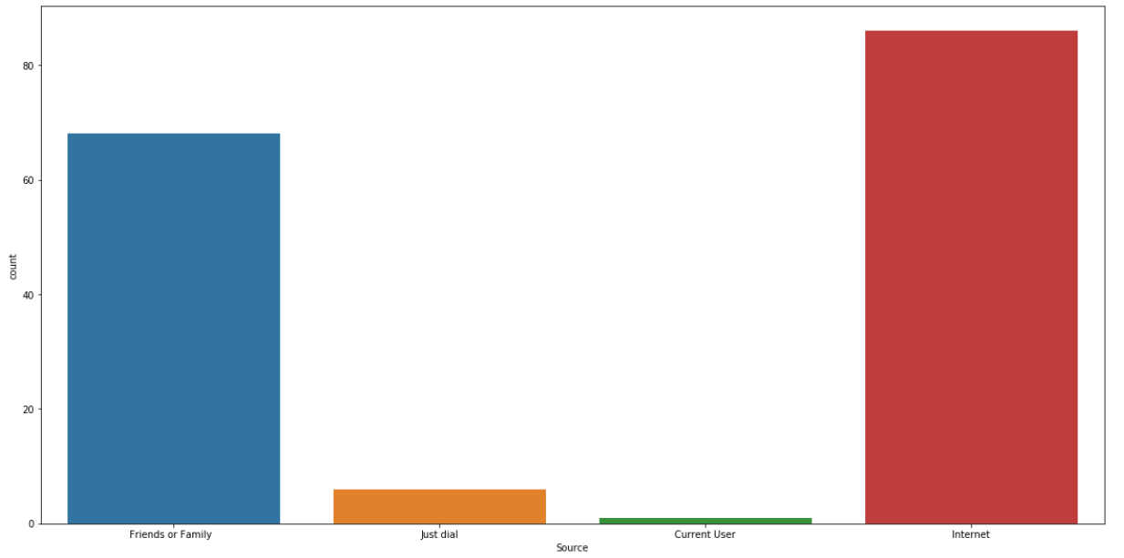

1. From the insights, we would recommend the underperforming dealers to reduce the quote values to increase sales.
2. According to our city wise analysis, we found that Chennai is leading in terms conversion rate as well as quote count. We would recommend the efforts should be focused on Kanchipuram and Thiruvallur.

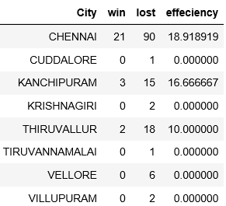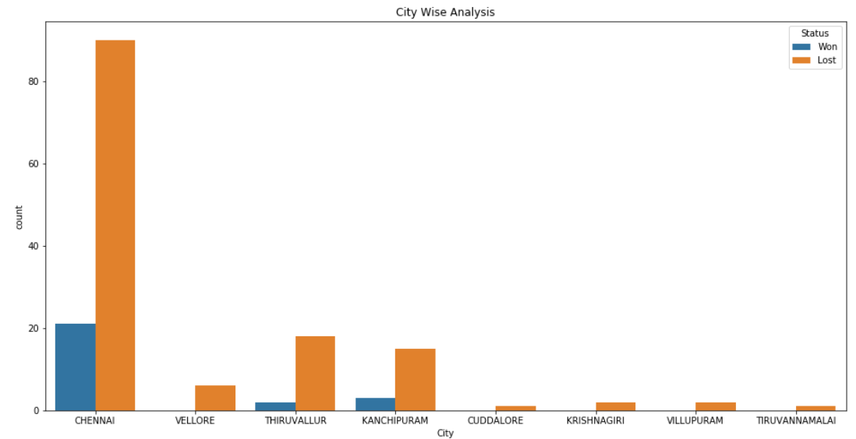

1. Another option for the company is to give the underperforming dealers a certain time to improve their conversion ratio by fixing price issues (raw material pricing ) as well as marketing issues, or else they will be dropped.
2. If the company does not have money to fix the underlying issues, we would also recommend getting rid of the under performing dealers and focus on the dealers that are performing well.